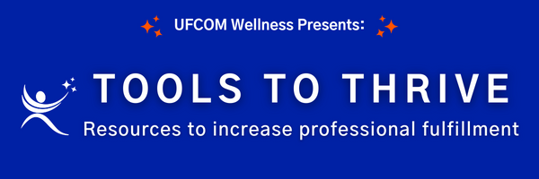

**Resources to Form Meaningful Connections with UF Faculty Colleagues**

***Meeting like-minded individuals can be challenging at any stage of life, but particularly with a busy faculty lifestyle.***

Connecting with colleagues can enhance your workplace \***culture of wellness**\* and significantly improve work-life wellbeing and professional fulfillment. The following resources can help you find and nurture relationships with [new] collaborators, colleagues, mentors, and friends.

1. **UF Faculty Affinity Groups:** <https://worklife.hr.ufl.edu/affinity-groups/>

Listing of existing UF faculty groups for professional networking and/or personal engagement with those who share common interests in hobbies, sports, food, parenting, volunteering, faith/culture, identity, and more!

1. **UFCOM Mentoring Dashboard:** [https://ufmedmentor.chronus.com/](https://nam10.safelinks.protection.outlook.com/?url=https%3A%2F%2Fufmedmentor.chronus.com%2F&data=05%7C01%7Clmerlo%40UFL.EDU%7Cea464313caf64a9e785b08db1023f32d%7C0d4da0f84a314d76ace60a62331e1b84%7C0%7C0%7C638121518807730832%7CUnknown%7CTWFpbGZsb3d8eyJWIjoiMC4wLjAwMDAiLCJQIjoiV2luMzIiLCJBTiI6Ik1haWwiLCJXVCI6Mn0%3D%7C3000%7C%7C%7C&sdata=LKbW3xneZW4%2Bw%2BZ0e52XZzisw2Xekf%2FHODijkAtErKY%3D&reserved=0)

Sign up now as a MENTOR, MENTEE, or BOTH to participate in the peer-to-peer mentoring program and find your match! Watch for new opportunities related to faculty onboarding and mentoring circles (coming soon!).

1. **VIVO (Research Collaborator Matching System):** <https://vivo.ufl.edu/>

VIVO is a research-focused discovery tool that enables collaboration among scientists across all disciplines. Browse or search information on people, departments, courses, grants, and publications to identify potential collaborators at UF and beyond.

1. **UF Centers and Institutes:** <https://ufhealth.org/centers-and-institutes>

Designed to create synergies and collaborative research opportunities, the Centers and Institutes focus on the interdisciplinary and  translational nature of biomedical research following the continuum from fundamental research, to clinical research, to patient care. Many host seminars, lectures, and networking opportunities for faculty and trainees.

1. **UFCOM Women in Medicine & Science (WIMS) Peer Mentoring Villages:** <https://facultyaffairs.med.ufl.edu/faculty-resources/women-in-medicine-and-science-wims/wims-villages/>

Short-term monthly peer mentoring groups for women faculty in the health science center colleges. Topics vary based on group leader preference. Don’t see a perfect fit? Sign up to start your own village!

1. **UFCOM New Faculty Boot Camp:** <https://facultyaffairs.med.ufl.edu/faculty-resources/online-resources-for-bootcamp/>

Monthly Zoom sessions for a cohort of new(ish) faculty to facilitate the transition to UF College of Medicine and help you start you off on the right track! Informative sessions and opportunities to meet and connect with near-peers. Missed out or can’t attend? *Recordings from previous sessions available online at the above link.*

1. **UFCOM Faculty Lounge:** <https://facultyaffairs.med.ufl.edu/faculty-resources/faculty-lounge/>

Located in UF Health Shands Hospital (North Tower) in room M-125, the Faculty Lounge is an ideal setting for meetings with colleagues. It also offers individual workspaces for faculty who come to the HSC campus and don’t have an office on-site. *FREE specialty coffees (cappuccino, mochaccino, latte, espresso) and teas are available for all UFCOM faculty in the lounge!* [Stop by the UFCOM Office if you need the door code].